SCM 517 - Group 401 - Case Study #1

Lucas Smith, Sravani Bolla, Sami Fahim, Kavya Murugan, Divyansh Shrivastava

Grocery Store Quality Costs

**Internal Failure Quality Costs**

AI Prompt: “Provide examples of internal failure quality costs for a grocery store”

1. **Expired or Spoiled Inventory**
   * If perishable goods go bad due to poor stock rotation or inadequate storage conditions, they must be discarded resulting in waste.
2. **Damaged Goods**
   * Grocery items may be damaged during storage, handling, or transport within the store. This results in them having to be written off – and ultimately a financial loss
3. **Rework Costs**
   * If products are mislabeled or improperly packaged (incorrect pricing tags or barcodes), the store must spend time and resources correcting the issues before they are ready for sale

**External Failures Quality Costs**

AI Prompt: “Provide examples of external failure quality costs for a grocery store”

1. **Customer Complaints**
   * Customer complaints cause the store to incur costs associated with resolving said complaints including labor and customer service resources
2. **Product Returns**
   * The return of expired/defective/poor quality products results in a loss of revenue and also incurred costs related to restocking and/or disposal
3. **Health and Safety Issues**
   * If a customer becomes ill due to consuming expired or contaminated food, the store could face legal liabilities which could be costly to resolve.

**Prevention Quality Costs**

AI Prompt: “Provide examples of prevention quality costs for a grocery store”

1. **Employee Training**
   * Costs related to ongoing training for staff on proper food handling, storage, stocking, customer service, etc.
2. **Inventory Management Systems**
   * Investments in Inventory management software to track stock levels, expiration dates, and forecasting
3. **Pest Control Programs**
   * Regularly implementing pest control measures in the store and storage areas to prevent contamination or damage to food products by pests such as insects or rodents.

**Appraisal quality costs**

AI Prompt: “Provide examples of appraisal quality costs for a grocery store”

1. **Quality Inspections** 
   * Costs associated with inspecting shipments of products to ensure items meet quality and freshness standards
2. **Customer Satisfaction Surveys**
   * Costs associated with gathering customer feedback
3. **Expiration Date Monitoring**
   * Costs associated with the labor involved in checking products on shelf and marking down or removing items that are nearing their expiration dates.

Cost Analysis

For the grocery store’s quality cost analysis, we assumed that it’s a well-established business with around 10 years of experience, reflecting a stable and mature operation.

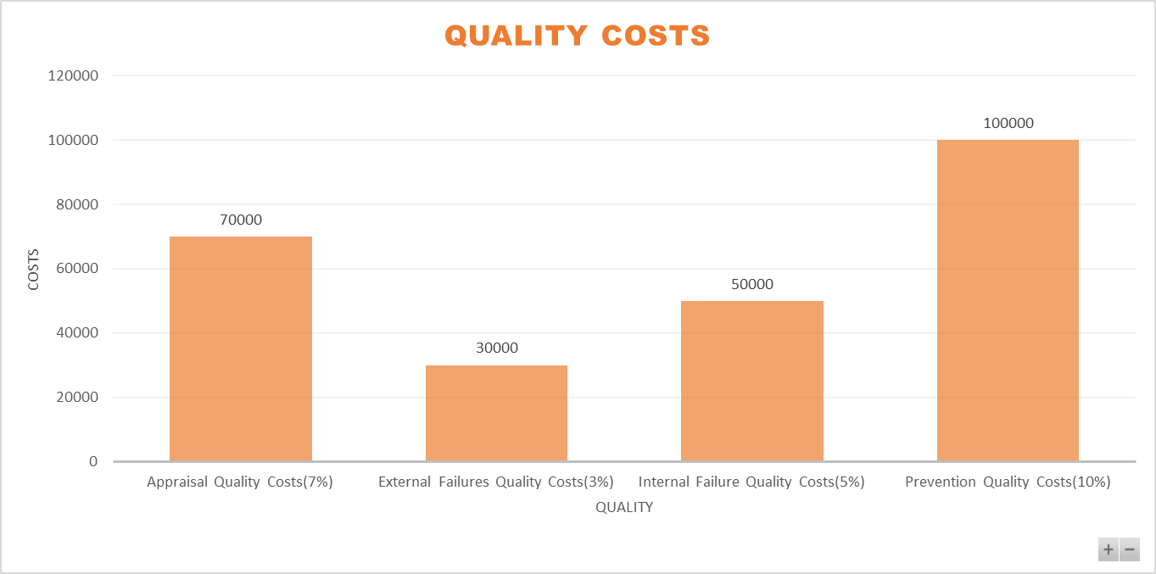

With an assumed history of effective quality management, we allocated higher costs to Prevention Quality Costs of 10% ($100,000), reflecting proactive measures such as inventory management and staff training to prevent issues. Appraisal Costs of 7%($70,000) are also substantial, representing regular quality checks. Internal Failure Costs of 5% ($50,000) and External Failure Costs of 3%($30,000) are comparatively lower, as we assumed preventive investments help minimize spoilage and complaints.

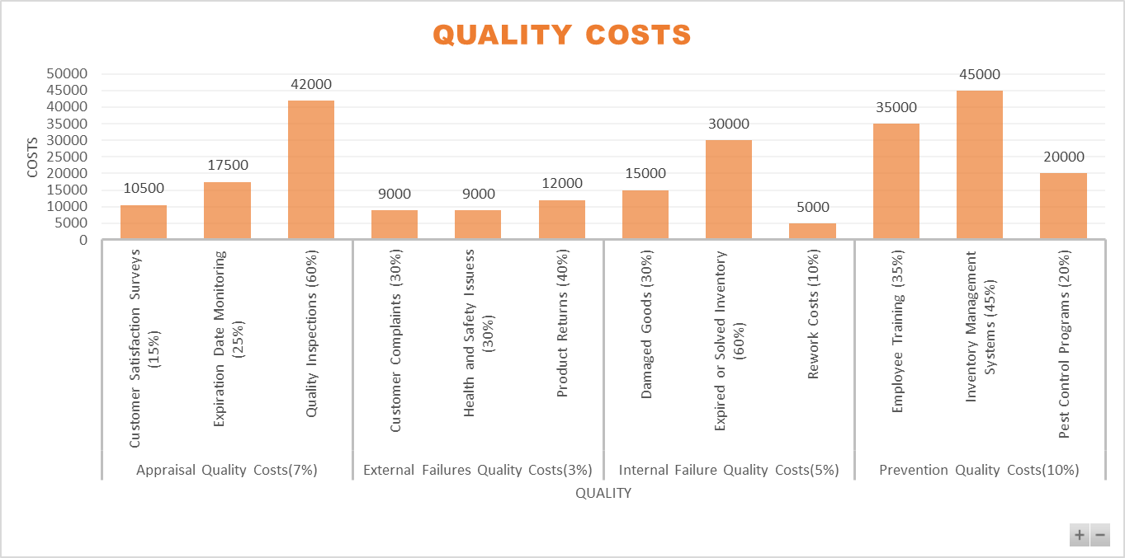

Appraisal Quality Costs ($70,000): We assumed higher spending on Quality Inspections of 60% ($42,000) due to frequent checks on perishable goods. Expiration Date Monitoring of 25% ($17,500) and Customer Satisfaction Surveys of 15% ($10,500) were also included to keep product quality and customer experience consistent. External Failures Quality Costs ($30,000): Costs like Customer Complaints of 30% ($9,000) and Product Returns of 40% ($12,000) reflect occasional quality lapses. Health and Safety Issues of 30% ($9,000) cover risks related to product handling.

Internal Failure Quality Costs ($50,000): We assumed higher costs for Expired or Spoiled Inventory of 60% ($30,000) and Damaged Goods of 30% ($15,000) due to handling perishable items. Rework Costs of 10% ($5,000) are minimal, as rework mainly involves minor packaging adjustments. Prevention Quality Costs ($100,000): Major expenses for Inventory Management Systems of 45% ($45,000) were assumed to ensure accurate stock levels and reduce waste. Employee Training of 35% ($35,000) helps staff handle products properly, while Pest Control Programs of 20%($20,000) are necessary to maintain cleanliness.

# 

# Process Charts

**Chart 1:**

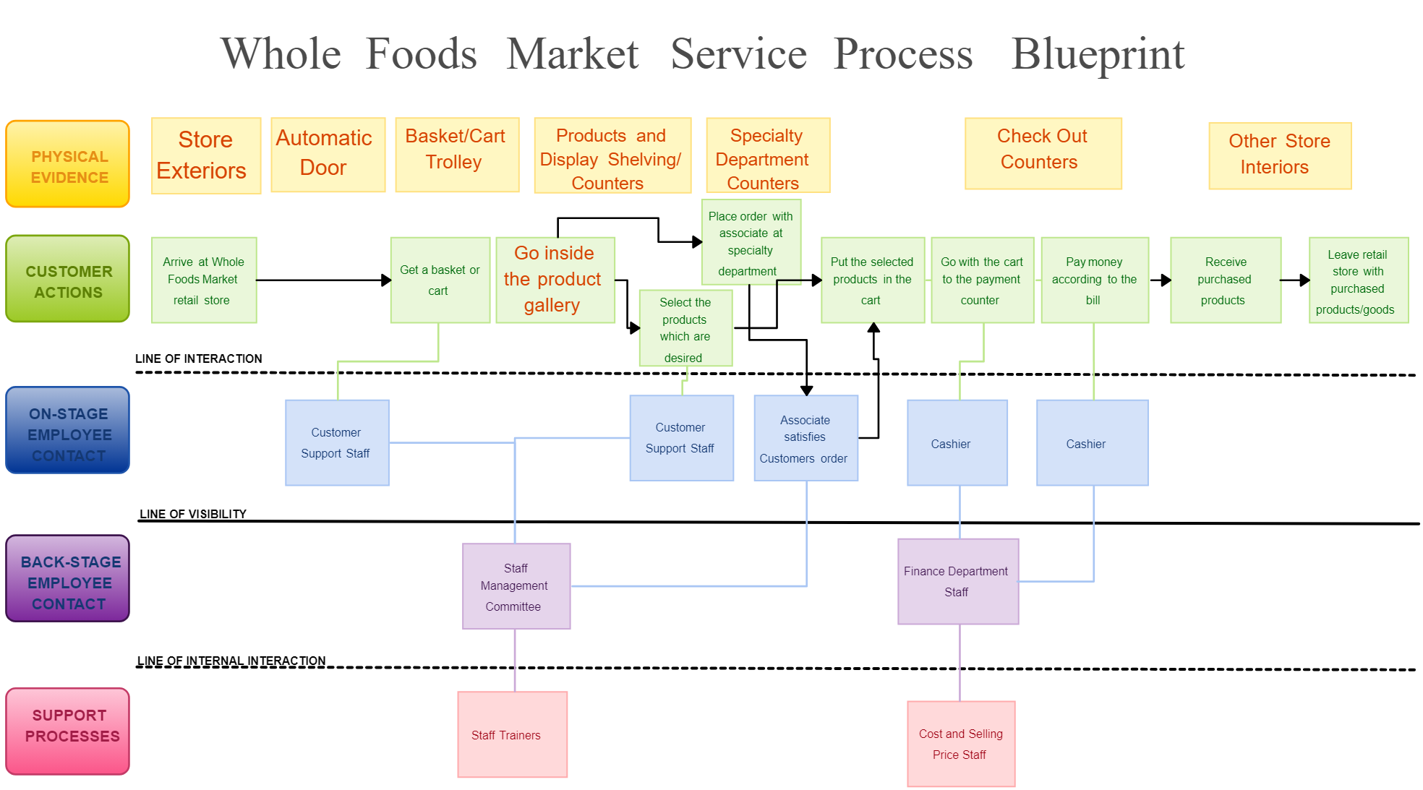

**Grocery Supply Chain Flow**

This process map outlines the movement of products from suppliers to grocery stores, focusing on key stages: food production, processing, warehousing, distribution centers, and delivery to stores. It highlights the importance of both local and global supply chains, especially for perishable goods like produce and dairy.

Key feature: Emphasizes seasonal and regional sourcing alongside international supply for non-local products.  
**Link:**[How the Grocery Supply Chain Works](https://www.datexcorp.com)

**Chart 2:**

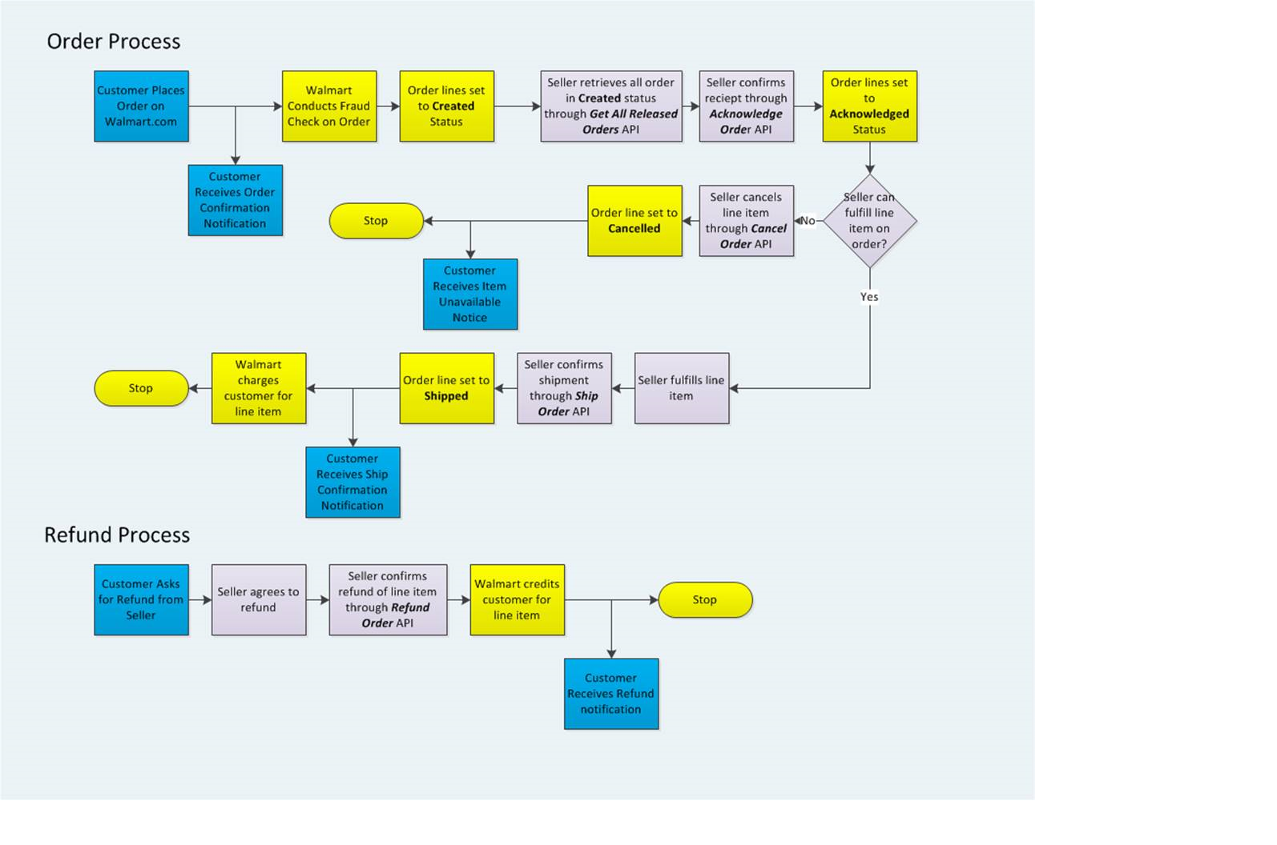

**Online Grocery Fulfillment Process**

This process map shows the steps involved in fulfilling online grocery orders, including order placement, picking, packing, and last-mile delivery to customers. The focus here is on integrating traditional supply chain operations with online platforms.

Key feature: Explains the importance of real-time order tracking and the shift towards hybrid grocery models (in-store and online).  
**Link:** [The Logistics of Online Grocery Shopping](https://www.allthingssupplychain.com/the-fascinating-world-of-grocery-retail-supply-chains/)

**Chart 3:**

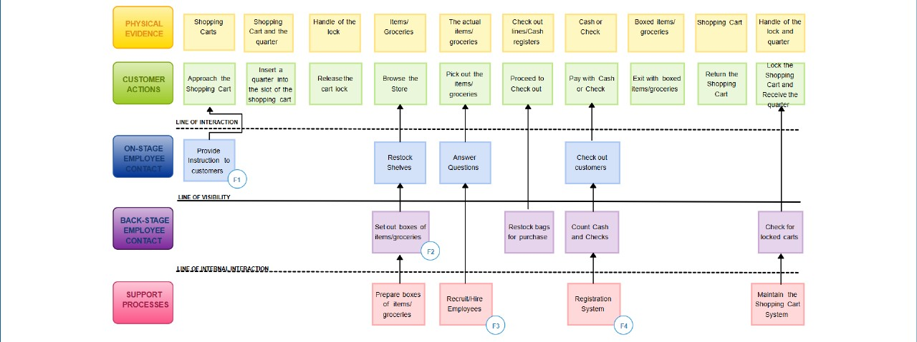

**Retail Store Replenishment Process**

This map demonstrates the internal inventory management process for grocery stores. It covers activities such as forecasting demand, placing orders, receiving stock, and shelf replenishment. Key decisions revolve around maintaining optimal stock levels to reduce shortages and waste.

Key feature: Highlights the role of just-in-time inventory and automated ordering systems to streamline replenishment and avoid stock-outs.

## **Similarities Across the Three Process Maps:**

1. **Customer Journey Focus:**

All three maps show end-to-end processes with a clear customer journey, from the start to the completion (e.g., shopping, checkout, order fulfillment).

1. **Multiple Touchpoints Involving Employees/Systems:**

Each process map involves stages where employees or systems (like cashiers, order systems, or sellers) interact with customers.

Front-line interaction: Retail staff (in Maps 1 & 2) and APIs confirming order details (Map 3).

1. **Defined Process Flow with Decision Points:**

Each map includes logical decision points (e.g., whether items are available, whether the cart is locked, or if the seller can fulfill the order).

**Key Differences Between the Process Maps:**

| **Particulars** | **Process Map 1 (Whole Foods)** | **Process Map 2 (ALDI)** | **Process Map 3 (Online Order - Walmart)** |
| --- | --- | --- | --- |
| Process Medium | Physical retail shopping | Physical shopping with cart mechanism | Fully online, automated process |
| Employee Visibility | Clear distinction between on-stage, back-stage, and support staff | Similar but fewer distinctions | No front-stage employee contact; system APIs manage fulfillment |
| Customer Actions | Browsing products, selecting items, interacting with employees | Using carts, browsing, paying at checkout | Placing an order online, receiving notifications |
| Decision Points | Choice of products to buy | Locking/returning carts, payment methods | Seller decision to fulfill or cancel order |
| Automation Level | Low (manual customer interactions) | Low (manual with some cart systems) | High (order APIs automate the process) |
| End Process | Customer exits with products | Customer returns cart and exits store | Order shipped or canceled based on stock availability |

### 

### Business Analytics Discussion

For this section, let’s consider **Walmart** as a specific company in the grocery store industry.

#### **Business Analytics Focus: Inventory Optimization**

Walmart discusses its use of advanced analytics to optimize inventory management on its website. They utilize data analytics to forecast demand accurately, ensuring that they stock the right items in the right quantities at the right time. This approach not only minimizes waste (especially for perishable goods) but also enhances customer satisfaction by ensuring product availability.

* **Example Insight**: Walmart's analytics help identify buying patterns during different seasons, enabling them to adjust inventory levels proactively. This strategy supports their commitment to reducing costs while providing a seamless shopping experience for customers.

Link: [Walmart - Supply chain - sustainability](https://corporate.walmart.com/purpose/esgreport/environmental/product-supply-chain-sustainability)

### **Company: Walmart**

**Business Analytics Focus: Inventory Optimization**

Walmart emphasizes the importance of advanced analytics in optimizing its inventory management. The company uses sophisticated data analytics to forecast demand accurately, ensuring that products are stocked in the right quantities at the right times.

**Key Points:**

* **Demand Forecasting:** Walmart analyzes historical sales data and seasonal buying patterns to predict customer demand. This allows the company to reduce excess inventory and minimize waste, particularly for perishable goods.
* **Supply Chain Efficiency:** By leveraging real-time data, Walmart can streamline its supply chain operations, ensuring timely restocking and reducing stockouts. This efficiency contributes to a smoother shopping experience for customers.
* **Customer Satisfaction:** The effective management of inventory helps maintain product availability, directly impacting customer satisfaction and loyalty.

**Example Insight:** During peak seasons or promotional events, Walmart's analytics enable the company to adjust inventory levels proactively. This adaptability not only supports their cost-reduction initiatives but also reinforces their commitment to sustainability by reducing waste.